Audio, Video Indexing & Retrieval

Project report submitted to

Indian Institute of Technology Kharagpur

in partial fulfilment for the award of the degree

of

Masters of Technology

in

Information and Communication Technology

By

Chandra Shekhar Sengupta

(Roll No:- 11IT61K14)

Under the guidance of

Dr. K. S. Rao

**School of Information Technology**

**INDIAN INSTITUTE OF TECHNOLOGY**

**KHARAGPUR**

November 2013



# CERTIFICATE

This is to certify that the thesis ‘**Audio, Video Indexing & Retrieval**’, submitted by **Chandra Shekhar Sengupta** (**11IT61K14**) in partial fulfillment of the requirements for the degree of Master of Technology in Information and Communication Technology, is a bonafide record of the work done by him in the School of Information Technology, Indian Institute of Technology Kharagpur, under my supervision and guidance.

**Dr. K. S. Rao** Signature

Associate Professor

School of Information Technology

Indian Institute of Technology Kharagpur, Date

India.

# DECLARATION

I certify that

a. The work contained in the report is original and has been done by myself under the guidance of my supervisor.

b. I have followed the guidelines provided by the Institute in writing the Report.

c. I have conformed to the norms and guidelines given in the Ethical Code of Conduct of the Institute.

d. Whenever I have used materials (data, theoretical analysis, and text) from other sources, I have given due credit to them by citing them in the text of the thesis and giving their details in the references.

.

Date:-

Chandra Shekhar Sengupta

Roll No:-11IT61K14

# ACKNOWLEDGEMENT

It gives me immense pleasure to express my sincere gratitude to **Dr. K. S. Rao**, under whose supervision and guidance, this work has been carried out. Without his advice and constant encouragement throughout, it would have been impossible to carry out this project work with confidence. It’s really a privilege to work under his guidance.

I would like to express my sincere gratitude to **Dr. Indranil Sengupta** for encouraging me to develop an App and Web based Service for Audio, Video Indexing.

I would also like to thank all faculty members of the School of Information Technology who have been extremely kind and helpful to me and motivated me from time to time to perform my level best.

Thanks to my family, friends and colleagues for listening to my ideas about this project and encouraging me.

Thanks a lot to Researchers, Open source world and bloggers who have provided so much information related to this project.

Chandra Shekhar Sengupta

School of Information Technology

Indian Institute of Technology

Kharagpur, India

# Abstract

Searching is the most performed activity in web as well as in local systems nowadays. We have so much of data around us which requires efficient searching to retrieve the most relevant results. Textual searching is becoming more advanced with the advent of latest technologies developed by Google, Microsoft. But huge amount of data available are in audio video format which are not efficiently searchable using existing search mechanism. We need better mechanism for indexing and searching audio, video data.

According to the 2011 update of Cisco's VNI IP traffic forecast, by 2015, [Internet](https://en.wikipedia.org/wiki/Internet) video will account for 61% of total Internet data.[[1]](http://allthingsd.com/20110601/cisco-the-internet-is-like-really-big-and-getting-bigger/)Surprisingly in 2010, Google had only indexed .004% of the data on the internet. These statistics help us understanding the need for more effective audio, video indexing & retrieval mechanism.

This report depicts a new approach for indexing & searching audio, video files and this mechanism will be well integrated with existing search engine [Google](http://www.google.com) and video-sharing website [YouTube](http://www.youtube.com) so that we can utilize existing ecosystems.

# CONTENTS

CERTIFICATE 2

DECLARATION 3

ACKNOWLEDGEMENT 4

Abstract 5

CONTENTS 6

List of Figures 8

Chapter 1: 9

Introduction 9

Thesis Organization 9

Motivation (Big data & mobile technology) 10

Proposed approach 13

Objective 15

Chapter 2: 16

Survey of Existing Works 16

Audio Video Search 16

Research Projects: 16

Commercial Products: 20

Music Search 21

Acoustic Fingerprinting 21

Query By Humming 22

Query by Melody 23

Reverse Image Search 24

TinEye 24

Google Search By Image 24

Bing Image Match 25

Yandex Image Search 25

Differentiating & Unique factors in our Approach 26

Chapter 3: 27

Architecture 27

Algorithm 29

Speech Recognition from Audio Video 29

Tag Determination Algorithm for texts from recognized speech 30

Tag Detection from Video Metadata Available from Websites 31

Object Detection from Video 32

Acoustic Information Detection from Audio 33

Tag With Timestamps File Format 34

Tag incorporation Algorithm 36

Indexing & Retrieval Environment 37

Individual Tag File based 37

Centralized Tags Database based 37

Integrated with Operating System Search Index 37

Video Retrieval Algorithm 38

Video With Generic Tags 38

Video Frame by Tags with Timestamp 39

Applications & Tools to be developed for this Approach 40

Case Studies 41

Single Video File from File System indexed for future retrieval 41

Multiple Videos File from Website indexed for future retrieval 42

Video Search within Organization 43

Complete Web based Video File indexing and retrieval 44

Chapter 4: 45

Implementation Details 45

Video file access: 45

Audio Indexing Process - Incorporation of Searchable keys 45

Audio Retrieval 46

Work Done So Far 46

Video Access & Manual Indexing Prototype 46

End to end flow implemented in 5th Semester 47

Web Client for Indexing YouTube Videos 48

Algorithms & Workflow 49

Work In Progress: 50

Image Object extraction 50

Clients for Accessing Videos 50

Research newer index keys 50

Work to be done in 6th Sem 50

Future Scope 51

Conclusions 52

References 53

# List of Figures

Figure 2: Amount of Global Data in last 15 years 10

Figure 3: Types of Searchable Data in Internet and their ratio 11

Figure 1 : Proposed Approach for Audio. Video Indexing & Retrieval 13

Figure 1 : General structure of MUVIS framework 16

Figure 1 : General Architecture of Rough n Ready framework 17

Figure 1 : Architecture of TalkMiner 18

Figure 1 : Architecture of SpeechBot 19

Figure 5: Overall Architecture 27

Figure 6: Speech Recognition from Audio, Video 29

Figure 7: Tag detection from recognized speech 30

Figure 8: Object Detection from Video 32

Figure 9: Acoustic Information Detection from Audio 33

Figure 9: Tags With Timestamps File Format 34

Figure 9: Tag Incorporation Mechanism 36

Figure 9: Video With Generic Tags Retrieval Mechanism 38

Figure 9: Video Frame Retrieval By Tags With Timestamp 39

Figure 9: ShabdoKhoj Applications & Tools 40

Figure 10: End to end flow implemented in 5th Sem 48

Figure 11: Web Client for Indexing YouTube Videos 49

# Chapter 1:

## Introduction

With the advent of essentially unlimited data storage capabilities and with the rapid use of the Internet, it should be possible to access any of the stored information with a few keystrokes or voice commands. Since much of this data will be in the form of speech and video from various sources, it becomes important to develop technologies necessary for indexing and browsing such audio, video data.

Human beings have amazing ability to distinguish different types of audio, video. Given any audio/video piece, we can instantly tell the type of audio (e.g., human voice, music or noise), type of video (e.g., content, ambience or noise), speed (fast or slow), the mood (happy, sad, relaxing etc.), and determine its similarity to another piece of audio, video. .[[3]](http://sipl.technion.ac.il/new/Teaching/Projects/Spring2006/2001%20-%20Indexing%20and%20Retrieval%20of%20Audio%20-%20A%20Survey.pdf)However, a computer sees a piece of audio/video as a sequence of sample values. At the moment, the most common method of accessing audio, video pieces is based on their titles or file names. Due to the incompleteness and appropriateness of the file name and text description, it may be hard to find audio, video pieces satisfying the particular requirements of applications.

With more and more audio, video being captured and stored, there is a growing need for automatic audio, video indexing and retrieval techniques that can retrieve relevant audio, video pieces quickly on demand.

## Thesis Organization

The thesis has been organized in the following way:-

Chapter 1 focuses on introduction, need, objective of a new audio, video indexing & retrieval system.

Chapter 2 discusses the related work in Audio, Video Indexing & Retrieval and the differentiating factor of our approach from the existing ones.

Chapter 3 Analyses its relevance by providing few case studies and proposes the Architecture & Algorithms for Audio, Video Indexing & Retrieval.

Chapter 4 contains the implementation work done so far, work in progress & future scope of work and pending areas.

Finally it concludes along with Reference resources.

## Motivation (Big data & mobile technology)

The Economist reports in its 2012 Outlook that the quantity of global digital data expanded from 130 Exabyte in 2005 to 1,227 in 2010, and is predicted to rise to 7,910 Exabyte in 2015.

An Exabyte is quintillion bytes. If you find that hard to visualize, consider this: someone has calculated that if you loaded an Exabyte of data on to DVDs in slim line jewel cases, and then loaded them into Boeing 747 aircraft; it would take 13,513 planes to transport one Exabyte of data. Using DVDs to move the data collected globally in 2010 would require a fleet of more than 16 million jumbo jets. .[[4]](http://idpl.oxfordjournals.org/content/2/2/47.extract)

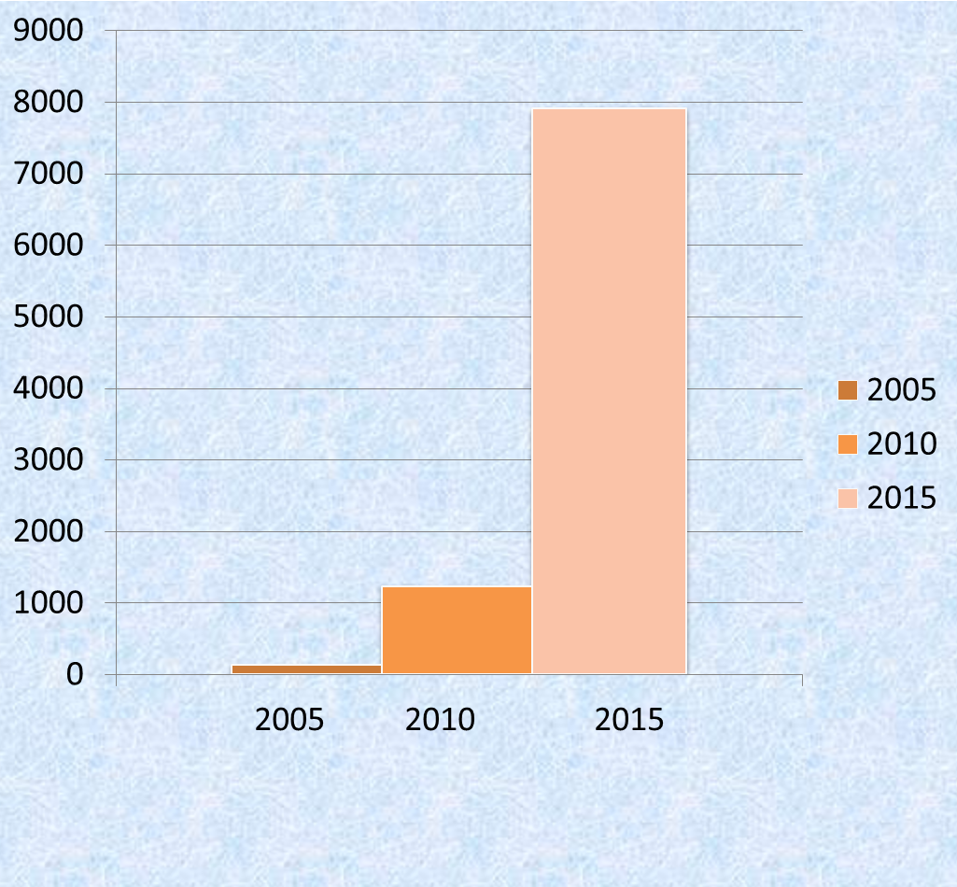

Figure 2: Amount of Global Data in last 15 years

And Exabyte are rapidly becoming passé. The volume of stored information in the world is growing so fast that scientists have had to create new terms, including zettabyte and yottabyte, to describe the flood of data. The importance of big data is not just a result of its size or how fast it is growing (about 60 per cent a year), but also the reality that the data come from an amazing array of sources. The Internet captures lots of data. Facebook alone has more than 800 million active users, more than half of whom log in every day, where they generate more than 900 million web pages and upload more than 250 million photos every day.

In 2010, a lifetime ago in Internet time, Google sites were used by more than 1 billion unique visitors every month who spent a collective 200 billion minutes on its sites. Google-owned YouTube passed 1 trillion video playbacks in 2011. Email, IM, VOIP calls, and other communications generate tens of trillions of recorded messages every year.

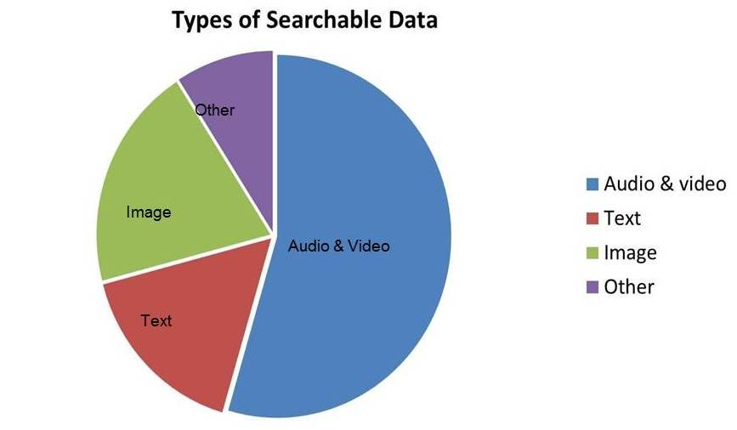

Figure 3: Types of Searchable Data in Internet and their ratio

People tend to visit the same sites frequently, so they don’t realize how truly ginormous the Internet really is. It is so big, that even with the millions of sites that Google has indexed, as of 2010; Google had only indexed **.004%** of the data on the Internet. Google had indexed 200 terabytes of the 5 million terabytes of information that existed on the Internet.

Netflix’s video-streaming service continues to be the most bandwidth-hungry application on the Internet, now accounting for a whopping 34.9% of all downstream traffic during peak periods on North American broadband networks, according to a new study.

The No. 1 subscription-video service outstripped all other services in terms of bandwidth consumption, as measured over a one-month period this fall by bandwidth-management vendor Sandvine. That’s up from Netflix’s 34.2% share in the first half of 2014 and 31.6% in the fall of 2013, according to the study. Netflix represented more than twice the bandwidth-usage of YouTube, which accounted for 14% of all peak-period downstream traffic in North America, compared with 18.9% in the second half of 2013, according to the [report](http://variety.com/2014/digital/news/netflix-streaming-eats-up-35-of-downstream-internet-bandwidth-usage-study-1201360914/).

The Cisco® Visual Networking Index (VNI) says that, Internet video & Audio will account for 61% of total Internet data by 2015.With the ever increasing amount of information being stored in audio and video formats, it is necessary to develop efficient methods for accurately extracting relevant information from these media with little or no manual intervention. [[5]](http://allthingsd.com/20110601/cisco-the-internet-is-like-really-big-and-getting-bigger/)

Here are few statistics related to internet videos.

* **4 billion –** Number of [hours of video](http://youtube-global.blogspot.se/2012/12/youtube-in-rewind-what-you-were.html) we watched on YouTube per month.
* **60 million –** Number of global [viewers](http://www.ustream.tv/blog/2012/12/20/ustreams-top-12-moments-of-2012/) monthly on Ustream.
* **14 million –** Number of Vimeo [users](https://vimeo.com/blog/post:542).
* **200 petabytes –** Amount of [video played](https://vimeo.com/blog/post:542) on Vimeo during 2012.
* **150,648,303 –** Number of unique visitors for video to Google Sites, the [number one video property](http://www.comscore.com/Insights/Presentations_and_Whitepapers/2012/State_of_the_Internet_in_Q3_2012) (September).
* **1 billion –** PSY’s [Gangnam Style](http://www.youtube.com/watch?v=9bZkp7q19f0) video became the first online video to [reach](http://youtube-global.blogspot.se/2012/12/ytvev.html) 1 billion views (currently just over 1.1 billion) and it achieved it in just 5 months.
* **2.7 billion –** Number of views of videos [uploaded](http://youtube-global.blogspot.se/2012/12/news-on-youtube-2012-in-review.html) to YouTube tagged Obama or Romney during the 2012 U.S. election cycle
* **2.5 million –** Number of hours of [news-related video](http://youtube-global.blogspot.se/2012/12/news-on-youtube-2012-in-review.html) that was uploaded to YouTube.
* **8 million –** The number of [concurrent viewers](http://youtube-global.blogspot.co.uk/2012/10/mission-complete-red-bull-stratos-lands.html) of the lifestream of Felix Baumgartner’s jump from the edge of space, the most ever on YouTube.
* **16.8 million –** Number of [total viewers](http://www.ustream.tv/blog/2012/12/20/ustreams-top-12-moments-of-2012/) in a 24 hour period for a video on Ustream, the most ever.
* **181.7 million –** Number of total unique viewers of online video in the U.S. during [December](http://www.comscore.com/Insights/Press_Releases/2013/1/comScore_Releases_December_2012_U.S._Online_Video_Rankings).

Few more statistics about Images

* **7 petabytes –** How much photo content Facebook [added](http://gigaom.com/cloud/facebook-has-220-billion-of-your-photos-to-put-on-ice/) every month.
* **300 million –** Number of new photos [added](http://gigaom.com/cloud/facebook-has-220-billion-of-your-photos-to-put-on-ice/) every day to Facebook.
* **5 billion –** The [total number of photos](http://blog.instagram.com/post/39142353889/year-in-review-instagram-in-2012-2012-has-been) uploaded to Instagram since its start, reached in September 2012.
* **58 –** Number of photos uploaded [every second](http://www.digitalbuzzblog.com/infographic-instagram-stats/) to Instagram.
* **1 –** Apple iPhone 4S was the most popular [camera](http://www.flickr.com/cameras/) on Flickr.

From the above discussion we can figure out following points:

1. Audio-Video is the most consumed data in the internet. So we have to improve the way user consume audio video data to cop up with **growing amount of data** available.
2. Users would like to get more relevant results when they search for audio, video data. So we need better **Audio video Indexing mechanism**.
3. Most of the time we spend so much time playing a video and looking for specific information. If we can tag video content with timestamp and provide a searchable interface so that you can search and play the video from desired timestamp. So we need better **Audio video Retrieval mechanism**.

## Proposed approach

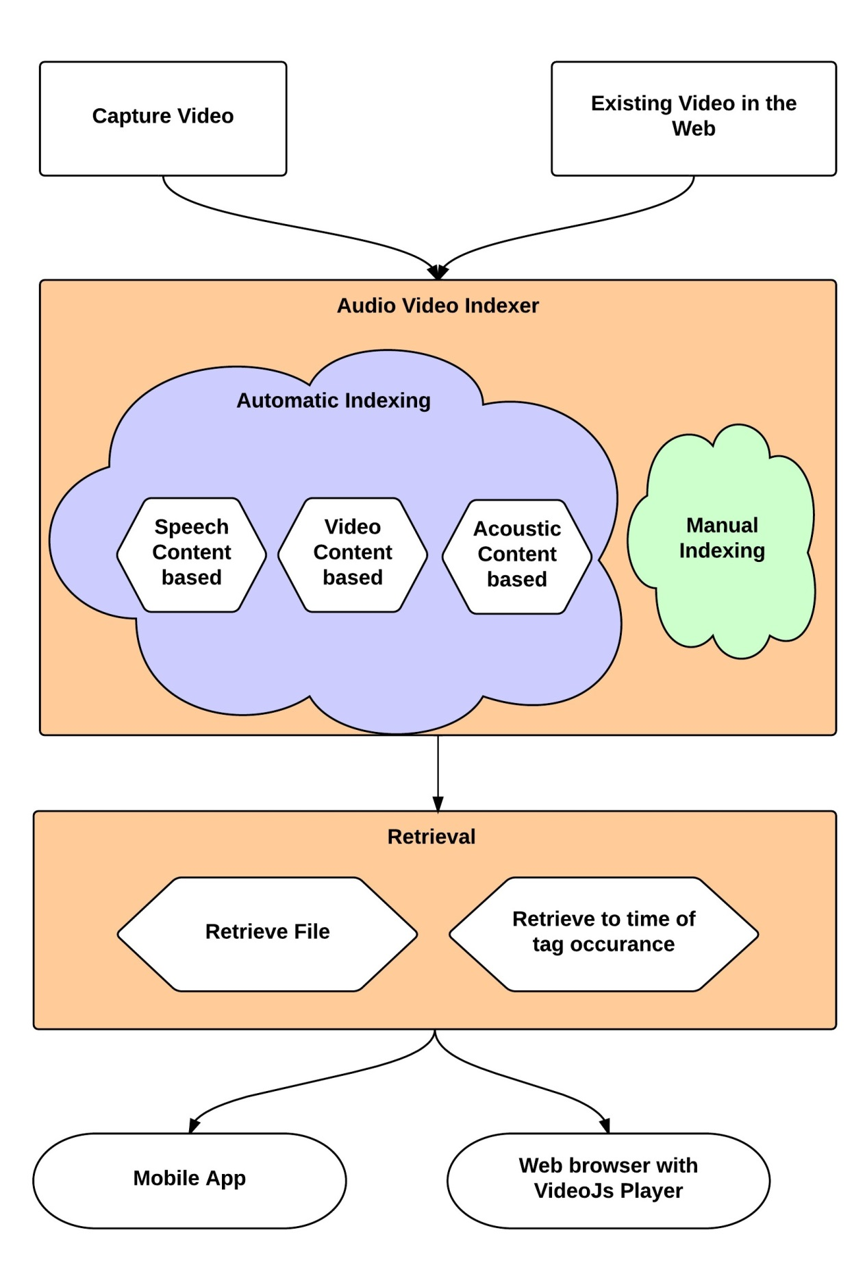

Figure 1 : Proposed Approach for Audio. Video Indexing & Retrieval

In this approach, we are extracting information about the video and audio content of the file from various aspects such as:

* Speech Content Based
  1. Speech to Text transform
  2. Existing Sub-Titles files
  3. Existing Captions
* Video Content based
  1. OCR from Video Frames
  2. Object detection from Video Frames
  3. Face detection from Video Frames
* Acoustic Content Based
  1. Background Noise Information
  2. Background Music Information
* And new approaches can be added in future as this will be a plug-in supported framework

Then we are determining most suitable tags and attaching them with file so that we can search & retrieve this file based on those tags.

We are also developing a video player which can associate tags with the video frames and retrieve to the desired video frame depending on user requirement.

## Objective

To summarize the motivation & objective of this project, following points can be mentioned:

* Current web search engines generally do not enable searches into audio, video files. Informative metadata/tags would allow searches into audio, video files, but producing such metadata is a tedious manual task. So we need to come up efficient automatic indexing algorithm for audio and video files.
* There are some very good indexing & retrieval technologies available for indexing music files. But not much for speech files.
* The main objective is to come up with an audio, video **indexing technique** which incorporates unique & searchable index keys for each audio, video file along with the manually entered metadata. Index keys will be determined from various aspects of the input file and most relevant tags will be chosen to index the file.
* Another objective is to develop a suitable **retrieval technique** of the exact video/audio content with respect to specific tag.
* To enable indexing & retrieving of existing videos / audios available in the web by developing a **platform that can co-exist & support existing ones**.

# Chapter 2:

## Survey of Existing Works

Audio, video related indexing & searching technology can be broadly divided into following major categories.

* Speech Search
* Music Search
* Video Frame Search

Notable researches done in these fields are listed below:

### Audio Video Search

#### Research Projects:

##### MUVIS

MUVIS is a framework for management (indexing, browsing, querying, summarization, etc.) of the multimedia collections such as audio/video clips and still images.

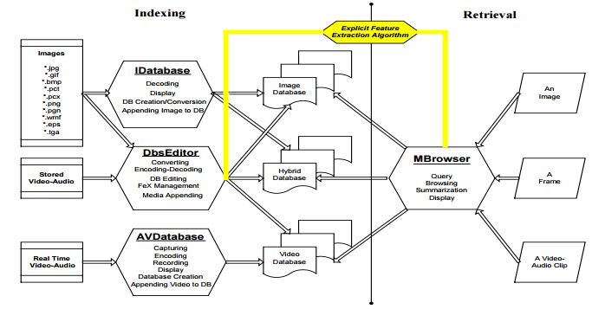

Figure 1 : General structure of MUVIS framework

MUVIS is a collaborative framework that supports indexing, browsing and querying of various multimedia types such as audio, video, audio/video interlaced in several formats. It allows real-time audio and video capturing, encoding by last generation codecs such as MPEG-4, H.263+, MP3 and AAC. MUVIS also supports several audio/video file format such as AVI, MP4, MP3 and AAC. MUVIS achieves a global and unified solution for content-based indexing and retrieval problem and provides user-friendly applications and a generic framework especially for third parties to develop their feature extraction modules.

##### Rough ‘n’ Ready

Rough ’n’ Ready indexes speech data, creates a structural summarization, and provides tools for browsing the stored data. The Rough ’n’ Ready system has focused entirely on the linguistic content contained in the audio signal and, thereby, derives all of its information from the speech signal. This is a conscious choice designed to channel all development effort toward effective extraction, summarization, and display of information from audio. This gives Rough ’n’ Ready a unique capability when speech is the only knowledge source.

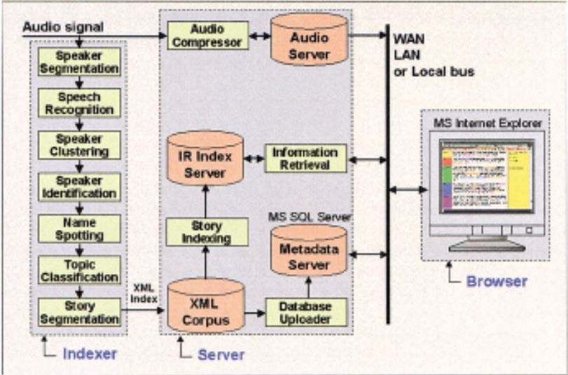

Figure 1 : General Architecture of Rough n Ready framework

Another salient feature of this system is that all of the speech and language technologies employed share a common statistical modeling paradigm that facilitates the integration of various knowledge sources.

##### Talk Miner

A new online video search tool launched recently makes it easier to search the content of video lectures by automatically transcribing words used in the lecturer’s visual aids. TalkMiner was created by researchers at Fuji Xerox Palo Alto Laboratory (FXPAL), in California, to help students and professionals search the ever-expanding online archives of video lectures and presentations.

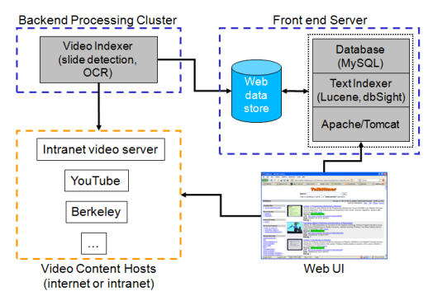

Figure 1 : Architecture of TalkMiner

TalkMiner builds a search index from words on the presentation slides in the source video. The system analyzes the video to identify unique slide images.

TalkMiner does not maintain a copy of the original video media files. The files are processed to produce metadata about the talk including the video frames containing slides and their time codes, and a search index constructed from the text recovered from those frames. When a user plays a lecture, the video is played from the original website on which the lecture webcast is hosted. As a result, storage requirements for the system are modest. The current prototype has indexed over 11,000 talks but it only requires approximately 11 GB of storage (i.e., 1 MB per talk).

##### SpeechBot

SpeechBot is a public search system (SpeechBot, 1999) similar to AltaVista which indexes audio from public Web sites such as Broadcast.com, NPR.org, Pseudo.com, and InternetNews.com. The index is updated daily as new shows are archived in their Web sites.

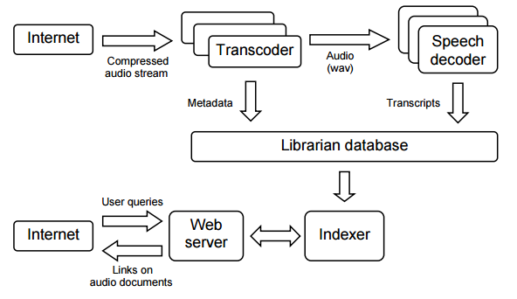

Figure 1 : Architecture of SpeechBot

SpeechBot is an audio search engine incorporating speech recognition technology. This allows indexing of spoken documents from the World Wide Web when no transcription is available. This site indexes several talk and news radio shows covering a wide range of topics and speaking styles from a selection of public Web sites with multimedia archives. This Web site is similar in spirit to normal Web search sites; it contains an index, not the actual multimedia content. The audio from these shows suffers in acoustic quality due to bandwidth limitations, coding, compression, and poor acoustic conditions. The shows are typically sampled at 8 kHz and transmitted, RealAudio compressed, at 6.5 kbps. Word-error rate results using appropriately trained acoustic models show remarkable resilience to the high compression, though many factors combine to increase the average word-error rates over standard broadcast news benchmarks. Even if the transcription is inaccurate, we can still achieve good retrieval performance for typical user queries (69%). Because the archive is large - over 5000 hours of content (and growing at a rate of 100 hours per week), totaling 47 million words and growing rapidly - we measure performance in terms of the precision of the top-ranked matches returned to the user.

#### Commercial Products:

##### Google Audio Indexing

In the 2008 presidential election race in the United States, the prospective candidates made extensive use of YouTube to post video material. Google developed a scalable system that transcribes this material and makes the content searchable (by indexing the meta-data and transcripts of the videos) and allows the user to navigate through the video material based on content. The system is available as an iGoogle gadget as well as a Labs product (labs.google.com/Gaudi). Given the large exposure, special emphasis was put on the scalability and reliability of the system.

Google's efforts to improve video search by using speech recognition technology started to become visible in July, when Google [launched a gadget](http://googlesystem.blogspot.com/2008/07/google-demoes-video-search-with-speech.html) for searching inside the political speeches from YouTube. The gadget has been expanded into a new service called [GAudi (Google Audio Indexing)](http://labs.google.com/gaudi), which is now available at Google Labs.

Although Gaudi is removed from iGoogle as well as Google Labs, it was a great and innovative approach towards Audio Indexing and retrieval.

##### HP Autonomy

The main technology, 'Intelligent Data Operating Layer' (IDOL), allows search and processing of text taken from database, audio, video or text files or streams. The processing of such information by IDOL is referred to by Autonomy as Meaning-Based Computing.

Autonomy's technology attempts to "understand" any form of unstructured information, including text, voice, and video, and based on that understanding perform automatic operations, for example inferring what the user wants and on that basis finding other information that may be of interest.

##### Microsoft Audio Video Indexing Service (MAVIS)

The Microsoft Audio Video Indexing Service (MAVIS) is a Windows Azure application which uses state of the art speech recognition technology developed at Microsoft Research to enable searching of digitized spoken content, whether they are from meetings, conference calls, voice mails, presentations, online lectures, or even Internet video. A side benefit of MAVIS is the ability to generate automatic closed captions and keywords which can increase accessibility and discoverability of audio and video files with speech content. At this time MAVIS supports English speech content. MAVIS is now available as a commercial service through a subscription to [**Greenbutton** **inCus**](http://incus.greenbutton.com/).

### Music Search

#### Acoustic Fingerprinting

An **acoustic fingerprint** is a condensed digital summary, [deterministically](http://en.wikipedia.org/wiki/Deterministic_algorithm) generated from an [audio signal](http://en.wikipedia.org/wiki/Audio_signal), which can be used to identify an [audio sample](http://en.wikipedia.org/wiki/Audio_sample) or quickly locate similar items in an audio database.[[1]](http://en.wikipedia.org/wiki/Acoustic_fingerprint#cite_note-1)

Practical uses of acoustic fingerprinting include identifying [songs](http://en.wikipedia.org/wiki/Song), [melodies](http://en.wikipedia.org/wiki/Melody), [tunes](http://en.wikipedia.org/wiki/Tune_(folk_music)), or [advertisements](http://en.wikipedia.org/wiki/Advertisements); [sound effect](http://en.wikipedia.org/wiki/Sound_effect) library management; and [video file](http://en.wikipedia.org/wiki/Digital_video) identification. Media identification using acoustic fingerprints can be used to monitor the use of specific musical works and performances on [radio](http://en.wikipedia.org/wiki/Radio) [broadcast](http://en.wikipedia.org/wiki/Radio_broadcasting), [records](http://en.wikipedia.org/wiki/Album), [CDs](http://en.wikipedia.org/wiki/CD) and [peer-to-peer](http://en.wikipedia.org/wiki/Peer-to-peer) networks. This identification has been used in copyright compliance, licensing, and other monetization schemes.

##### Shazam

Shazam have developed and commercially deployed a flexible audio search engine. The algorithm is noise and distortion resistant, computationally efficient, and massively scalable, capable of quickly identifying a short segment of music captured through a cellphone microphone in the presence of foreground voices and other dominant noise, and through voice codec compression, out of a database of over a million tracks. The algorithm uses a combinatorial hashed time-frequency constellation analysis of the audio, yielding unusual properties such as transparency, in which multiple tracks mixed together may each be identified.

#### Query By Humming

**Query by humming** (**QbH**) is a music retrieval system that branches off the original classification systems of title, artist, composer, and genre. It normally applies to songs or other music with a distinct single theme or melody. The system involves taking a user-hummed [melody](http://en.wikipedia.org/wiki/Melody) (input[query](http://en.wikipedia.org/wiki/Information_retrieval)) and comparing it to an existing [database](http://en.wikipedia.org/wiki/Database). The system then returns a ranked list of music closest to the input query.

One example of this would be a system involving a [portable media player](http://en.wikipedia.org/wiki/Portable_media_player) with a built-in [microphone](http://en.wikipedia.org/wiki/Microphone) that allows for faster [searching](http://en.wikipedia.org/wiki/Search_engine_technology) through [media](http://en.wikipedia.org/wiki/Digital_media) files.

The [MPEG-7](http://en.wikipedia.org/wiki/MPEG-7) standard includes provisions for QbH music searches.

##### SoundHound

SoundHound is revolutionizing the way people interact with mobile devices by delivering innovative technologies and compelling user experiences in sound recognition. SoundHound's breakthrough [Sound2Sound](http://www.soundhound.com/index.php?action=s.sound2sound) technology searches sound against sound, bypassing traditional sound to text conversion techniques even when searching text databases. [Sound2Sound](http://www.soundhound.com/index.php?action=s.sound2sound) has resulted in numerous breakthroughs including the world's fastest music recognition, the world's only viable singing and humming search, and instant-response large scale speech recognition systems.

##### Sound2Sound (S2S) Search Science

Sound2Sound (S2S) Search Science is a revolutionary technology, created by SoundHound, capable of recognizing various sound inputs including music and speech. It offers a breakthrough combination of speed and accuracy unattainable through traditional approaches to sound recognition.S2S performs recognition by extracting features from the input signal and converting them to a compact and flexible Crystal representation. This Input Crystal is then matched against a database of Target Crystals which have been derived from searchable content.

##### Tunebot

**Tunebot** is a music search engine developed by the Interactive Audio Lab at [Northwestern University](http://en.wikipedia.org/wiki/Northwestern_University). Users can search the database by humming or singing a melody into a microphone, playing the melody on a virtual keyboard, or by typing some of the lyrics. This allows users to finally identify that song that was stuck in their head.

**Searching Techniques**

Tunebot is a Query by humming system. It compares a sung query to a database of musical themes by using the intervals between each note. This allows a user to sing in a different key than the target recording and still produce a match. The intervals are also unquantized to allow for other tunings besides the standard A=440Hz, since not many people in the world have perfect pitch.

#### Query by Melody

Music Retrieval based on Melodic Similarity, which is one type of content-based retrieval, is proposed. Every fragment of a melody is represented as an appropriate N-dimensional vector, called a feature vector. A feature vector consists of values corresponding to intervals and rhythm of a melody. Depending on the distance between every fragment of a melody in the music database to the entered melody, k-nearest melodies can be obtained quickly using the SS-tree.

##### Musipedia

Musipedia offers three ways of searching:

* Based on the melodic contour,
* based on pitches and onset times, or
* based on the [rhythm](http://en.wikipedia.org/wiki/Rhythm) alone.

The melodic contour search uses an editing distance. Because of this, the search engine finds not only entries with exactly the contour that is entered as a query, but also the most similar ones among the contours that are not identical. Similarity is measured by determining the editing steps (inserting, deleting, or replacing a character) that are needed for converting the query contour into that of the search result. Since only the melodic contour is relevant, one can find melodies even if the [key](http://en.wikipedia.org/wiki/Key_(music)), [rhythm](http://en.wikipedia.org/wiki/Rhythm), or the exact [intervals](http://en.wikipedia.org/wiki/Interval_(music)) are unknown.

The pitch and onset time-based search takes more properties of the melody into account.

The "query by tapping" method that only takes the rhythm into account uses the same algorithm as the pitch and onset time method, but assumes all pitches to be the same. As a result, the algorithm can be used for tapped queries that only contain onset times.

### Reverse Image Search

Reverse image search is content-based image retrieval (CBIR) query technique that involves providing the CBIR system with a sample image that it will then base its search upon; in terms of information retrieval, the sample image is what formulates a search query. In particular, reverse image search is characterized by a lack of search terms. This effectively removes the need for a user to guess at keywords or terms that may or may not return a correct result. Reverse image search also allows users to discover content that is related to a specific sample image, popularity of an image, and discover manipulated versions and derivative works.

#### TinEye

TinEye is a reverse image search engine. You can submit an image to TinEye to find out where it came from, how it is being used, if modified versions of the image exist, or to find higher resolution versions. TinEye is the first image search engine on the web to use image identification technology rather than keywords, metadata or watermarks. It is free to use for non-commercial searching.

[TinEye](https://www.tineye.com) regularly crawls the web for new images, and we also accept contributions of complete online image collections. To date, TinEye has indexed 10,974,401,835 images from the web to help you find what you're looking for.

#### Google Search By Image

Google Images has a Search by Image feature for performing reverse image searches. Unlike traditional image retrieval, this feature removes the need to type in keywords and terms into the Google search box. Instead, users search by submitting an image as their query. Results may include similar images, web results, pages with the image, and different resolutions of the image. For example, if you search using a picture of a beach, you might get results including similar beaches, information about the same beach, and websites that use the same beach picture.

The precision of Search by Image's results is higher if the search image is more popular. Additionally, Google Search by Image will offer a "best guess for this image" based on the descriptive metadata of the results.

#### Bing Image Match

Called Image Match, Bing’s reverse image search offers a more streamlined version of what Google has been offering; only displaying the information you absolutely need, as well as a multiple sizes of the image you’re looking up. On top of all that, the Image Match feature is incredibly easy to use. Bing has made it as easy as possible to find the Image Match tool. All you need to do is go to “bing.com/images” here and click on “Image Match,” which will be displayed to the right of the search field at the top of the screen. After adding an image’s URL or uploading an image, Bing will display the results it finds on a search results page.

With Bing, site descriptions are omitted, giving a much cleaner look. The various sizes that are available are also listed at the top of the screen.

#### Yandex Image Search

Russian Search Engine giant Yandex provides a reverse image search service as well. You can find similar images or group of images easily and quickly using Yandex image search engine.

## Differentiating & Unique factors in our Approach

Our approach has following differentiating & unique factors which makes this worth implementing:

1. Integration of index keys available from three major components of a video/audio file
2. Index key determination algorithm(tag cloud) based on relevancy
3. Categorization of Index keys based on Acoustic information
4. Index keys with time frame
5. New file format for storing index keys for audio/video files as plug-n-play
6. Most of the existing research projects for audio video indexing do not integrate properly with existing audio video websites like [Youtube](https://www.youtube.com/), [Vimeo](https://vimeo.com), [Netflix](https://www.netflix.com/global), [Ustream](http://www.ustream.tv) etc. We will enable integration with existing platforms.
7. Integration with YouTube upload and existing contents of Youtube
8. Most of the existing research projects are not optimized for audio video indexing in mobile devices. But most of the audio/videos are being captured by mobile devices nowadays. We are optimizing this platform for providing audio/video indexing capabilities while capturing via mobile device.
9. Retrieval from mobile device
10. Retrieval from web
11. Retrieval by time frame
12. New video player extension for supporting this audio/video indexing approach

# Chapter 3:

## Architecture

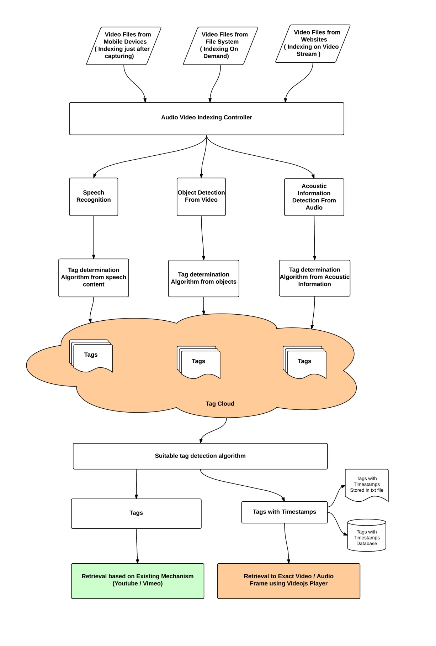

Figure 5: Overall Architecture

In this approach Audio Video indexing controller will extract following information from input file and route them corresponding processors.

* Speech Content 🡪 Speech Content Processor
* Image Object 🡪 Image Object Processor
* Acoustic Information 🡪 Acoustic Information processor

These processors will segregate the specific contents and pass through corresponding **Tag determination Module**.

Now tags from all sources will form a **Tag cloud** for the input file. Now we will run **Relevant Tags Detection Algorithm** to choose most suitable tags for the input file. Now finalized tags will be associated with the input file. Timestamps associated with tags will be stored in Timestamp database.

While audio retrieval there are two options available:

1. Retrieve based on tags from existing websites like YouTube , Vimeo
2. Retrieve based timestamp using our **tag with timestamp database.**

## Algorithm

### Speech Recognition from Audio Video

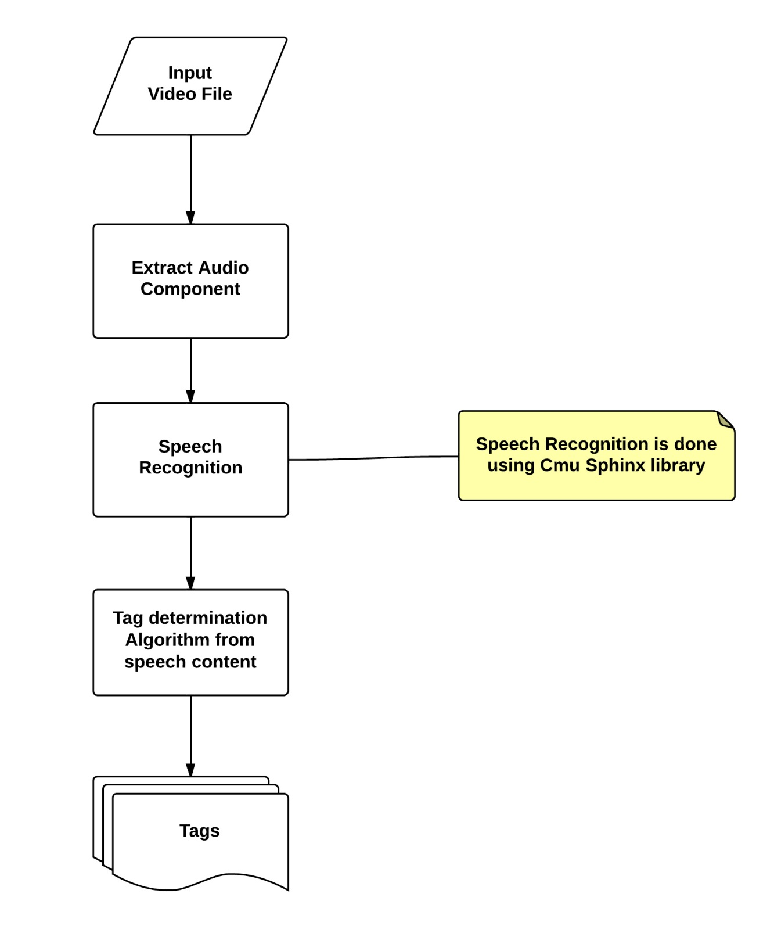

Figure 6: Speech Recognition from Audio, Video

### Tag Determination Algorithm for texts from recognized speech

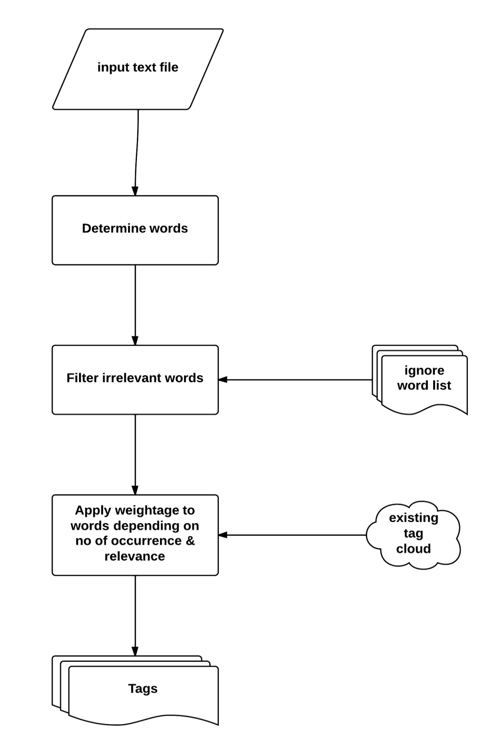

Figure 7: Tag detection from recognized speech

### Tag Detection from Video Metadata Available from Websites

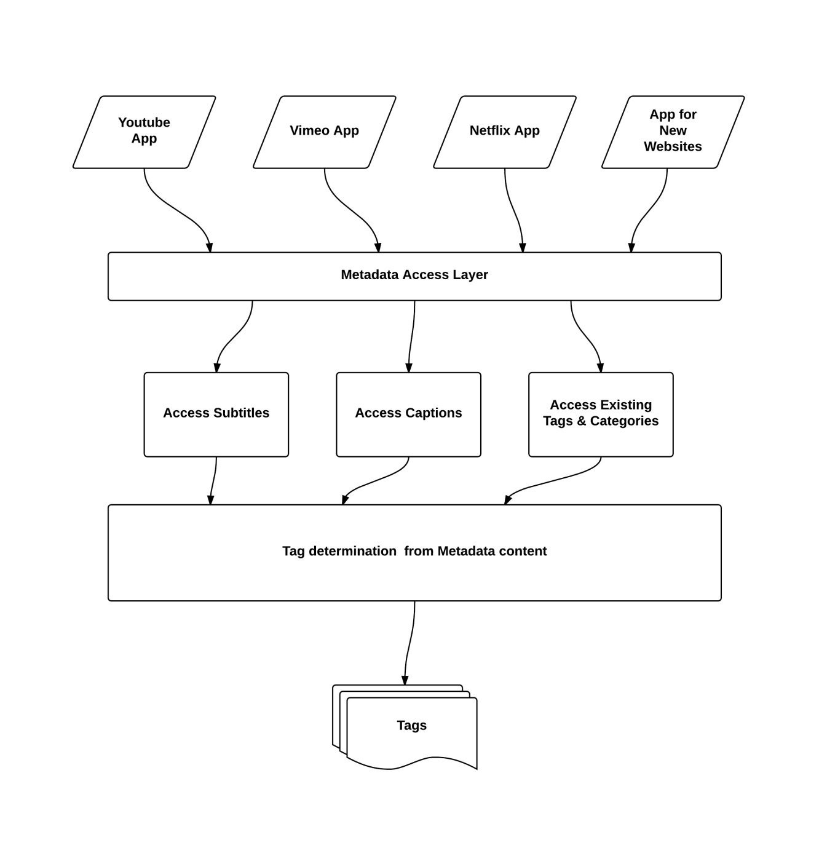

### Object Detection from Video

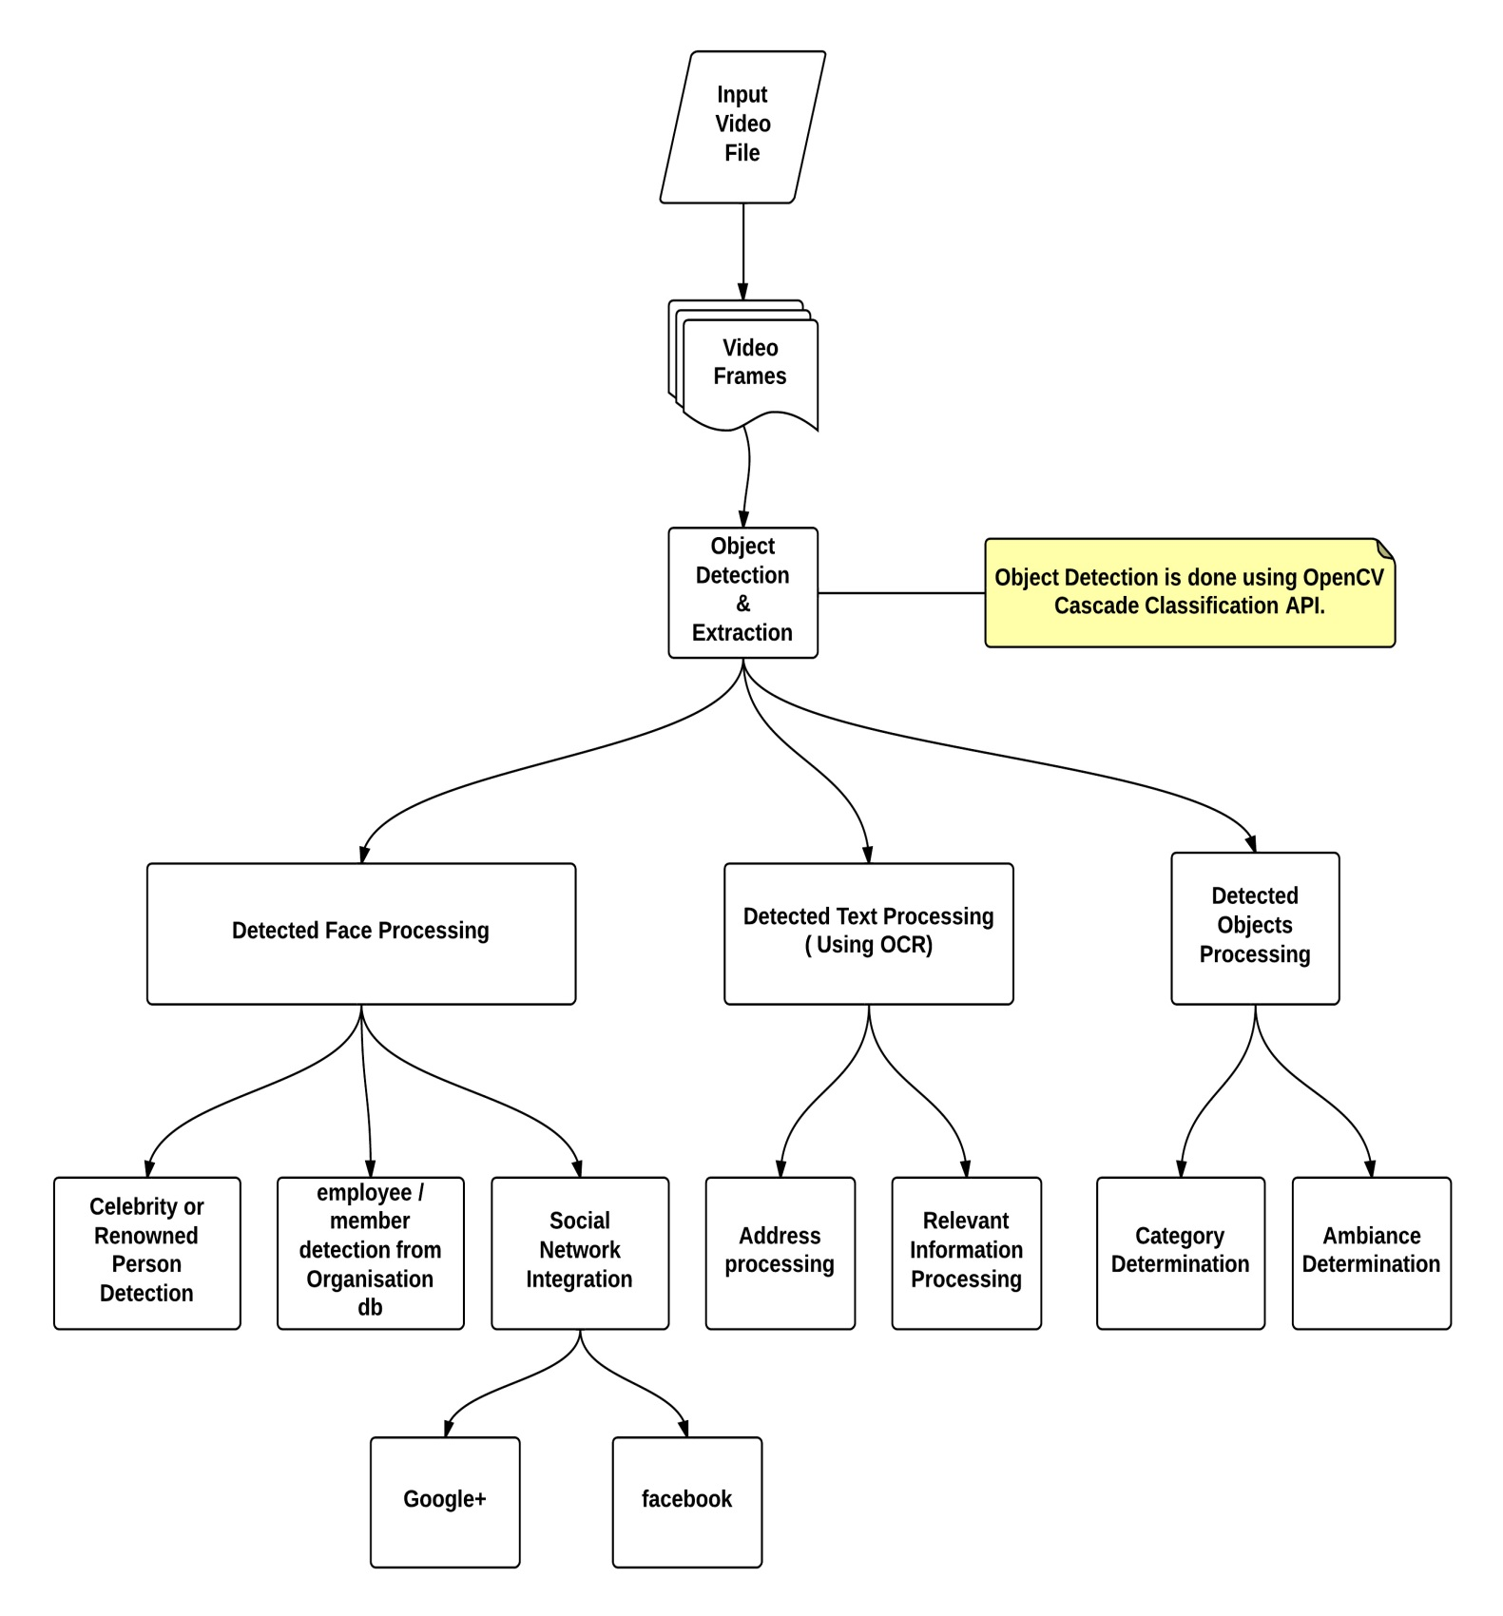

Figure 8: Object Detection from Video

### Acoustic Information Detection from Audio

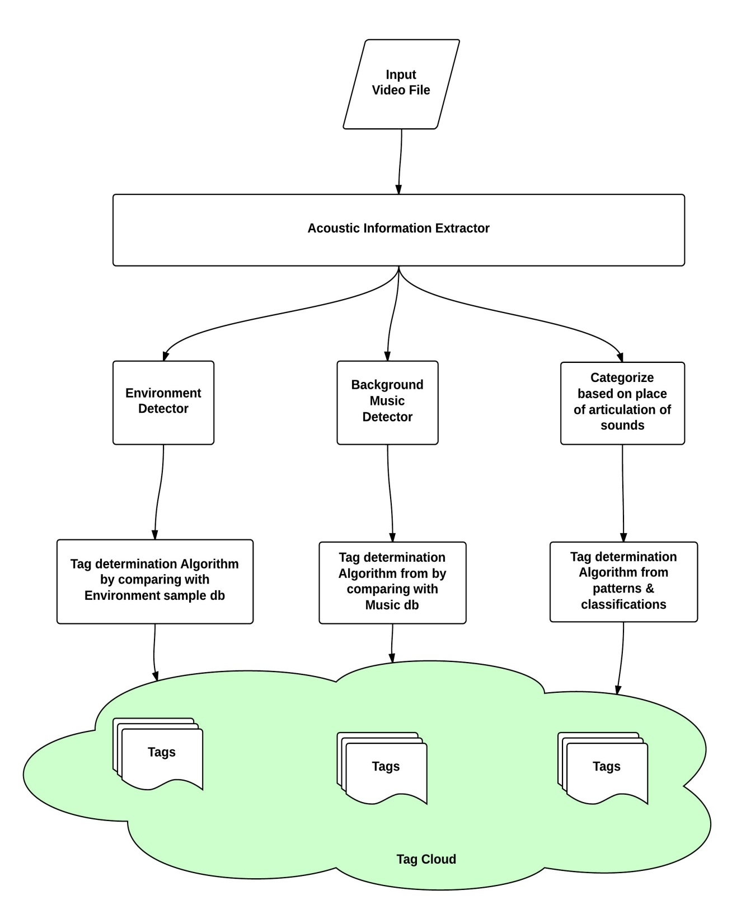

Figure 9: Acoustic Information Detection from Audio

### Tag With Timestamps File Format

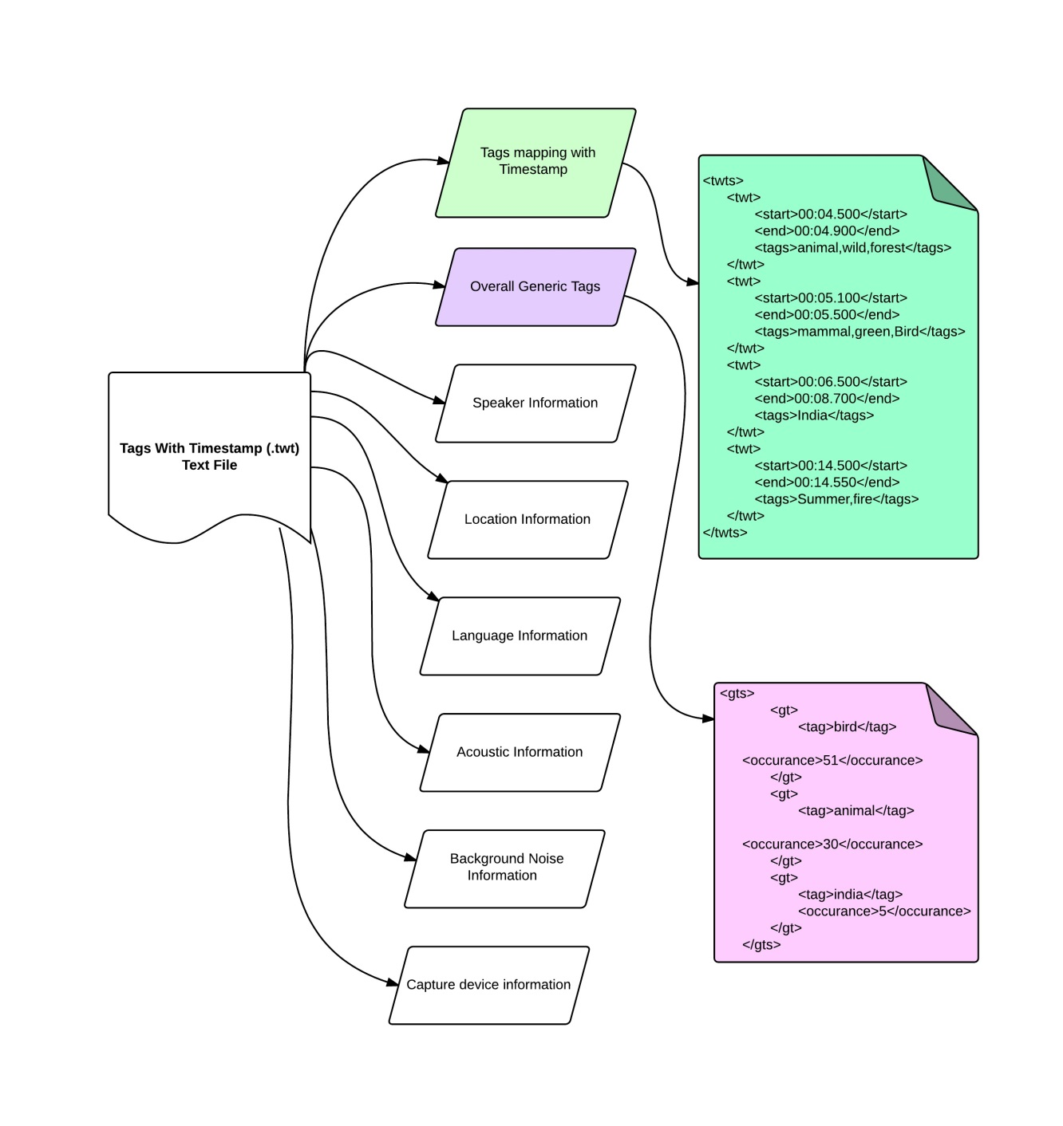

Figure 9: Tags With Timestamps File Format

**Tags With Timestamps** file format can be represented in XML or JSON. In the scope this project we will work on following two elements

* Tags With Timestamps (twts)
  + Start time (start)
  + End time (end)
  + Tags (tags)
* Generic Tags (gts)
  + Tag Name (tag)
  + Number of Occurrence ( occurrence)

The root element of all kinds of tags is <**avir>** (Audio Video Indexing & Retrieval).

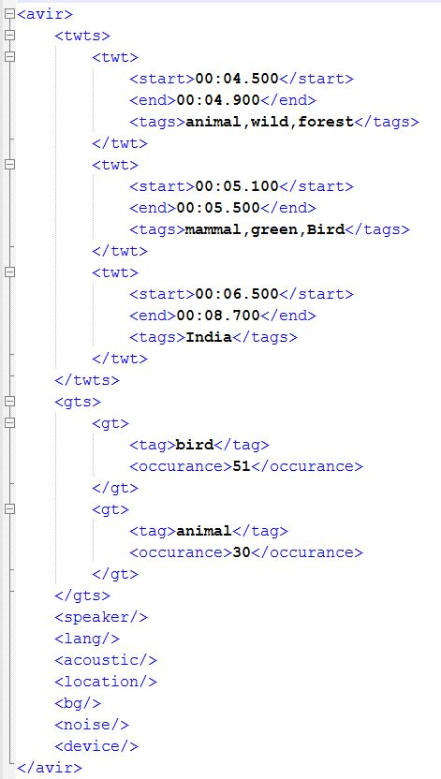

### Tag incorporation Algorithm

We are going to follow a generic approach for incorporating tags with indexed Video/Audio Files so that we can support almost all the videos available online and offline.

Video files can be accessed from following sources –

* File system (offline)
* Web ( online)

Corresponding Tag/index information of video/audio file can reside in following ways

* a file available in file system or hosted in web
* a centralized database
* stored as EXIF information of the video file
* Pushed to Host Website’s (Youtube , Vimeo) tags
* Integrate with Operating System Search Index

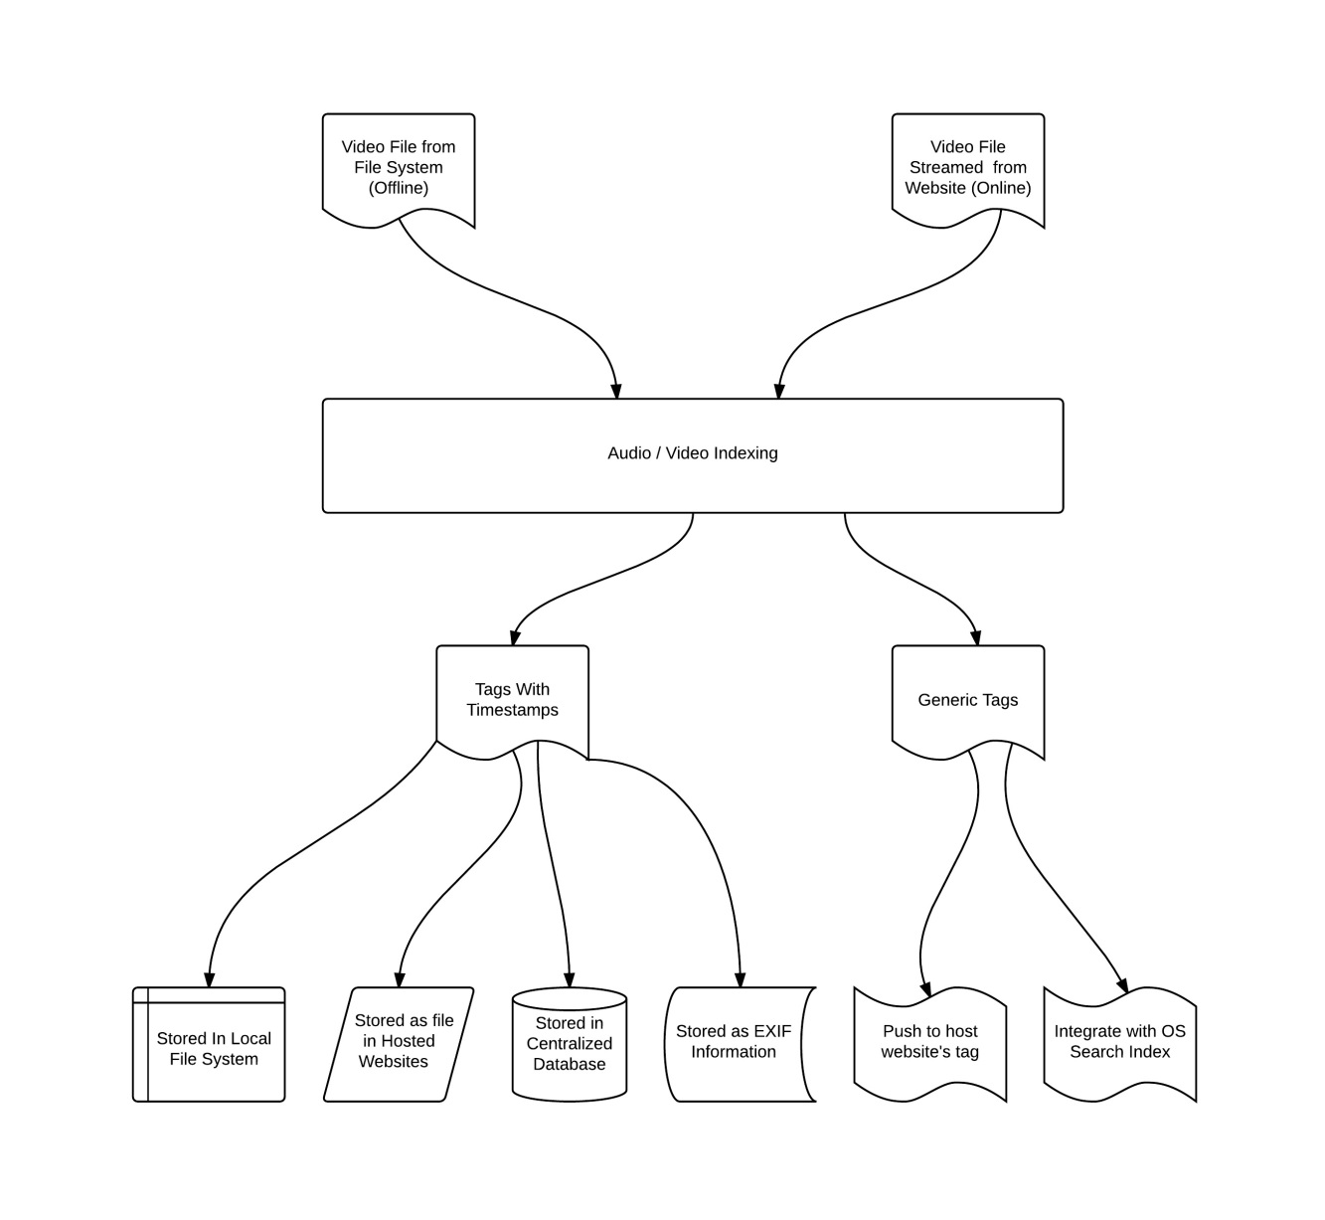

Figure 9: Tag Incorporation Mechanism

### Indexing & Retrieval Environment

The scope of indexing and retrieval of audio/video files depend on the environment as well.

#### Individual Tag File based

Our Audio Video Indexing Mechanism will generate tag information and store it as a separate text file. User can use this tags file to browse through the corresponding video file. User can choose not to integrate this information with a centralized database and Operating System’s Search Indexes.

#### Centralized Tags Database based

Centralized Tags Database can enable searching through all the video files with indexed keys along with timestamp based retrieval as well. This architecture can be deployed in local system as well as in websites.

#### Integrated with Operating System Search Index

We can integrate indexes derived from this approach with Windows operating systems [federated search](https://technet.microsoft.com/en-us/library/dd744682(v=ws.10).aspx#WS_DeployingSearchConnectors) index repositories. This will enable efficient and faster search and retrieval of the indexed audio/video files.

### Video Retrieval Algorithm

Our indexing approach can integrate index keys as tags in various ways as mentioned earlier. So there can be following two types of retrieval mechanism:

#### Video With Generic Tags

Video with generic tags should not require any special mechanism for retrieval other than the existing ones. Normal search queries with the desired tags should fetch the video file and generic video player should be available to play the video.

And Video websites also should fetch the video with desired search keywords as tags are already pushed to website’s indexing platform.

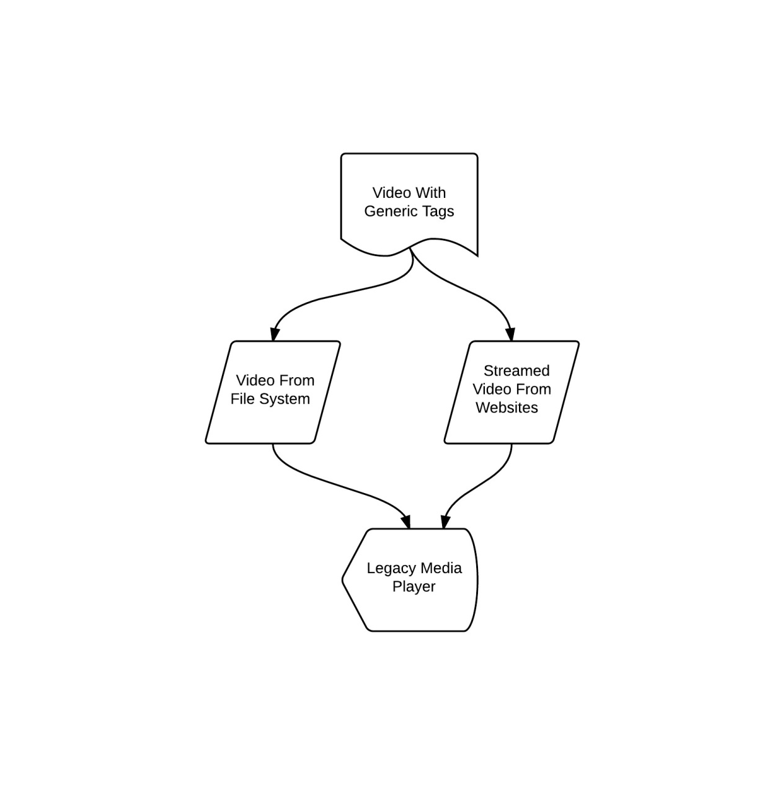

Figure 9: Video With Generic Tags Retrieval Mechanism

#### Video Frame by Tags with Timestamp

We can retrieve video frames by searching for associated tags using enhanced VideoJs Player. Our indexing mechanism associates tags with timestamp of the video frame and saves into the **Tags With Timestamps (TWT)** File. Depending on the location of Video and TWT file there are six combinations as described in the below diagram. We have enhanced VideoJs Player to support all six combination of retrieval.

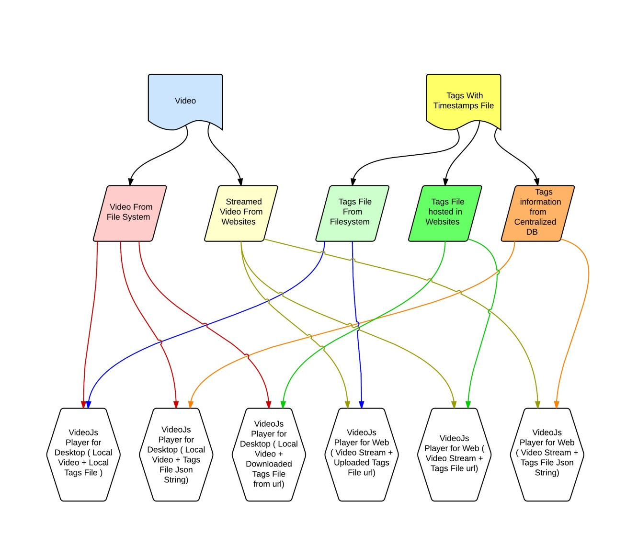

Figure 9: Video Frame Retrieval By Tags With Timestamp

## Applications & Tools to be developed for this Approach

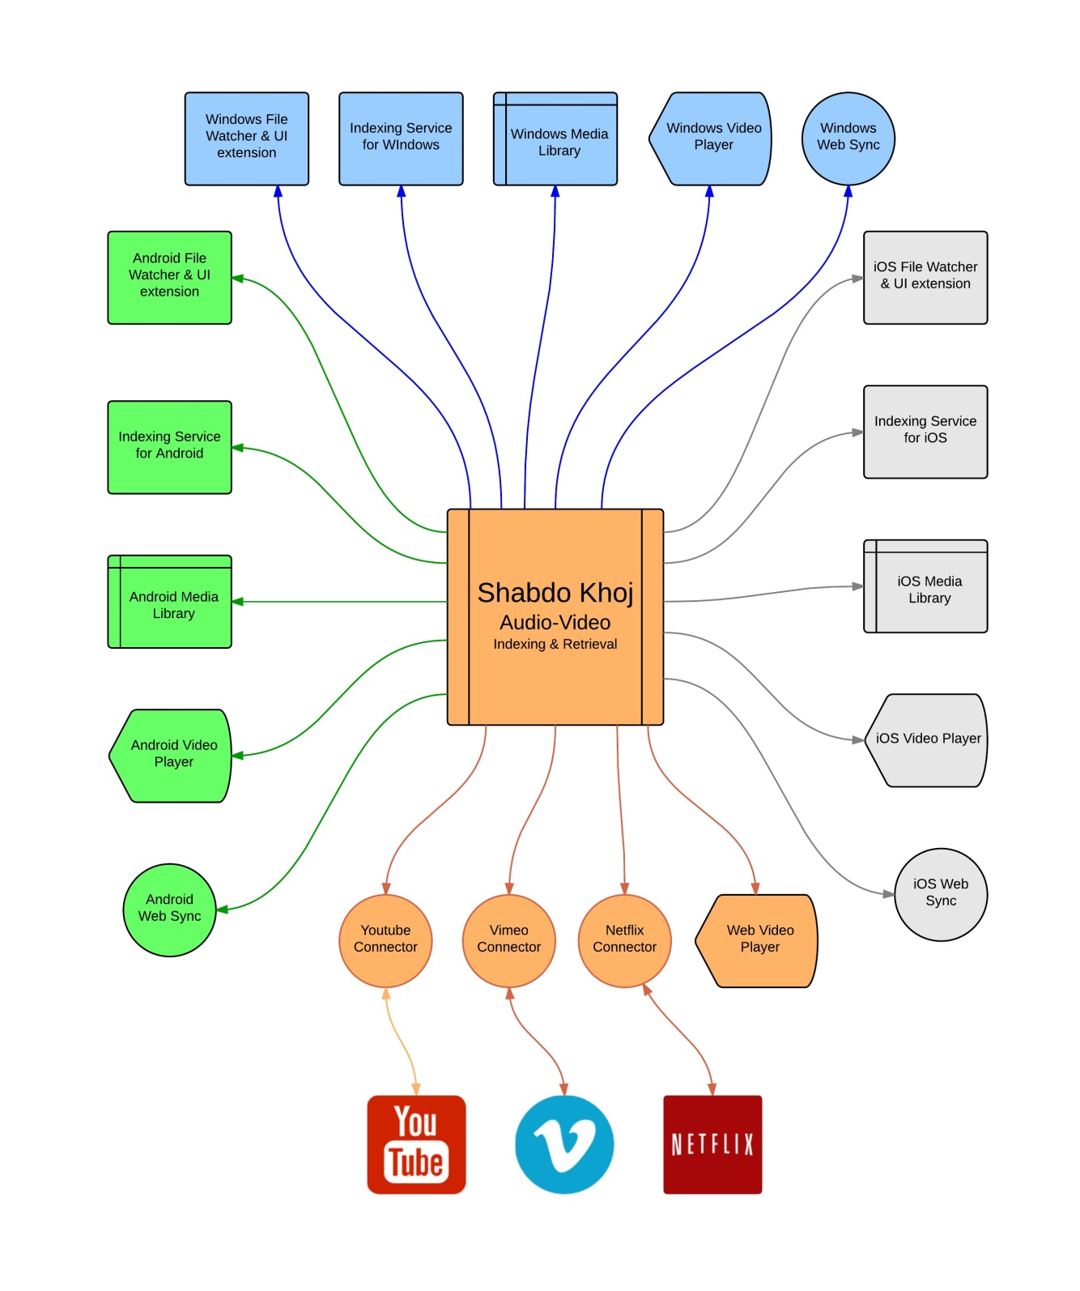

Figure 9: ShabdoKhoj Applications & Tools

## Case Studies

### Single Video File from File System indexed for future retrieval

##### Problem

1. 35 min long video file present in the file system.
2. Video consists of sports news update of EPL & La Liga football teams.
3. User is interested to watch news portion related to EPL club Manchester United and La Liga Club Barcelona.
4. User does not want to spend more than 2 min of time watching the relevant content.

##### Solution

###### Indexing

1. User can open up VideoJs Player With **ShabdoKhoj** Extension
2. User queues the video for indexing.
3. Index the video file from OCR text, Recognized Speech, Metadata etc and record corresponding time stamp with tags.
4. Create a tag cloud; determine suitable tags with timestamp for the file.
5. **Tags with Timestamp** for the video is saved in the file system
6. Let’s say, Barcelona, Manchester United, Man U tags appear in the 5th min , 19th Min and 27th Min.

###### Searching & Retrieval

1. **Tags With Timestamp** file for the Video file is linked to VideoJs Player UI after completion of Indexing.
2. Now user can search the tags to see when ‘barca’ tags are present (e.g.: 5th min). User can fast forward to 5th min and watch the relevant content
3. User can add this video file and its indexing information to **ShabdoKhoj** Library for future use

### Multiple Videos File from Website indexed for future retrieval

##### Problem

1. User has 3 YouTube video URL and 2 Vimeo video URL which describes about devastating Nepal Earthquake 2015.
2. Videos consist of news update & social media updates of earth quake with total running time of **4 hours**.
3. User has to prepare a report about activity of Indian Government’s **National Disaster Response Force**.
4. User does not want to spend more than **30 min** of time watching the relevant content.

##### Solution

###### Indexing

1. User can open up VideoJs Player With **ShabdoKhoj** Extension
2. User creates a playlist by adding all 5 URL and queue it for indexing.
3. Index the video files from OCR text, Recognized Speech, Metadata etc and record corresponding time stamp.
4. Create a tag cloud; determine suitable tags with timestamp for the file.
5. Tags with Timestamp files for videos are saved in the file system
6. Let’s say, **National Disaster Response Force**, **Indian Government**, and NDRF tags appear in the 15th min, 29th Min and 47th Min of 1st video and so on.

###### Searching & Retrieval

1. **Tags With Timestamp** file for the Video files are linked in the VideoJs Player UI
2. Now user can search the tags to see when ‘NDRF tags are present (e.g.: 15th min). User can fast forward to 15th min and watch the relevant content. User can repeat the same process for remaining 4 videos as well.
3. User can add these video files and their indexing information to **ShabdoKhoj** Library for future use

### Video Search within Organization

##### Problem

1. 2 days remaining for End Semester examination. Total time available for preparation is Maximum 30 hours.
2. 30 x 3 = 90 video lectures available, which will take 90 hours to play.
3. Video titles are corrupted somehow. So it is not possible to identify the important lectures quickly.

##### Solution

###### Indexing

1. User can open up VideoJs Player With **ShabdoKhoj** Extension
2. User creates a playlist by adding all 90 videos and queue those for indexing.
3. Index the video files according to Speaker, Creation Time, Capture Location, Recognized Speech, Metadata etc.
4. Index videos by Image object , Image text, Background noise & Acoustic information
5. Create a tag cloud, determine suitable tags with file.
6. Tags with Timestamp files for videos are saved in the file system

###### Searching & Retrieval

1. **Tags With Timestamp** file for the Video files are linked in the VideoJs Player UI
2. Now User can Open the Tag Browser for videos added in playlist
3. Retrieve According to Speaker : Ksrao, Rsc, Sc
4. Retrieve According to Creation Time & Sort.
5. Retrieve According to Capture Location
6. Retrieve According to Recognized Speech content
7. Retrieve According to User defined metadata / tag
8. Retrieve According to Acoustic information

### Complete Web based Video File indexing and retrieval

##### Problem

1. User has to study around 100 YouTube videos (Running time 50 hours) from [Berklee College of Music](https://www.youtube.com/channel/UCS3dfr0uOIC6OP-rSECVPMA) which describes about Musical activities happening in that college.
2. Videos consist of Musical Collaboration, Fusion music, Jamming sessions & social media updates.
3. User has to analyze Indian fusion Music activity happening in [Berklee College of Music](https://www.youtube.com/channel/UCS3dfr0uOIC6OP-rSECVPMA) so that user can opt to apply in that college.
4. User does not want to spend more than **3 hours** of time watching the relevant content.

##### Solution

###### Indexing

1. User can open up VideoJs Player with **ShabdoKhoj** Extension for Web.
2. User creates a playlist by adding Youtube Channel URL and queue it for indexing.
3. Index the video files from OCR text, Recognized Speech, Metadata etc and record corresponding time stamp.
4. Create a tag cloud; determine suitable tags with timestamp for the file.
5. Tags with Timestamp files for videos are saved in the **Centralized Database** hosted in Web
6. Let’s say, **Indian Music**, **Indian Classical**, **Fusion** and **A R Rahman** tags appear in 5 videos and so on.

###### Searching & Retrieval

1. **Tags With Timestamp** file for the Video files are linked in the VideoJs Player UI
2. Now user can search the tags to see when (e.g.: 15th min) and in which video (e.g.: 11th video) ‘**Indian**’ tags are present. User can fast forward to 15th min and watch the relevant content. User can repeat the same process for matching videos as well.
3. User can add these video files and their indexing information to **ShabdoKhoj** Library for future use

# Chapter 4:

## Implementation Details

### Video file access:

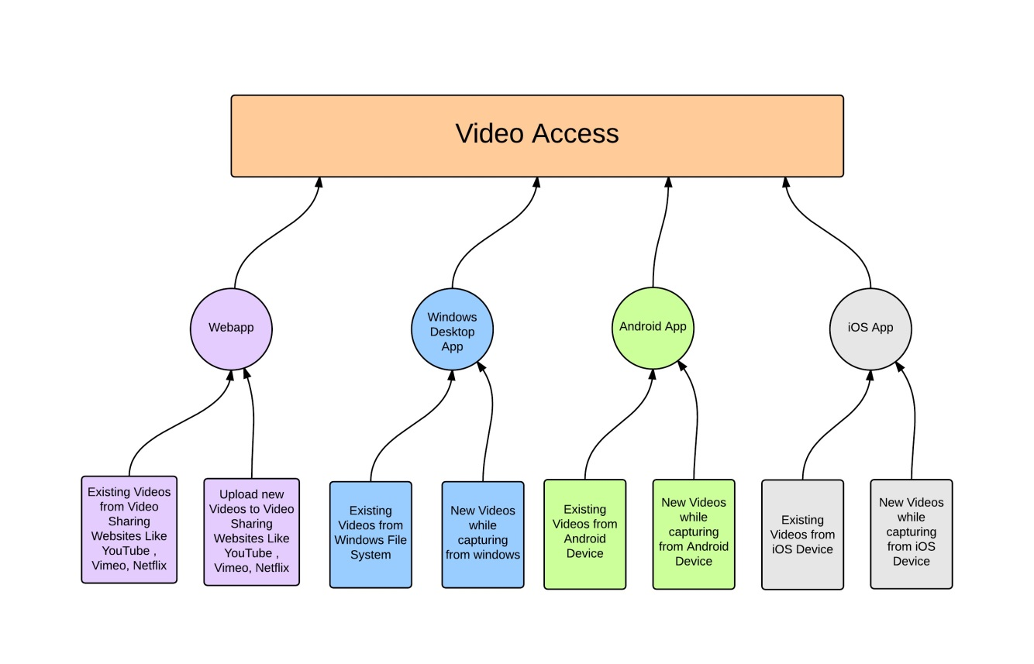

Figure 9: ShabdoKhoj Video Access Options

Video Access is the most important aspect for us. We should be able to access existing videos as well as videos while capturing. Most of the videos are captured from mobile devices or accessed from online video sharing websites. I have written apps in four different platforms to enable video indexing better.

#### Windows App for Video Access

Windows App for Video Access will have 4 ways of adding a new file for indexing. Such as:

* **File Browser** : User can browse the file system to add desired file for indexing
* **File system Watcher:** User can add folders to watch list. Whenever a new file added in the Watch Listed Folders, it will be automatically queued for indexing.
* **File Explorer Menu Integration** : User can right click on a video file and add the file for indexing by clicking on menu item – “Index With ShabdoKhoj”
* **New Video File Capture**: User will get an option for indexing the video file while capturing video with Webcam or attached camera device.

#### Android App for Video Access

#### iOS App for Video Access

#### Web App for Video Access

Video files can be accessed from existing websites like:

1. YouTube
2. Vimeo
3. Netflix
4. Google Drive
5. DropBox

But these websites do not allow accessing raw video file using APIs. So we will have another option to upload video files from our Uploader. Our uploader will perform the audio indexing process before uploading to the websites and attach the index keys.

### Audio Indexing Process - Incorporation of Searchable keys

I need to come up with a better algorithm for incorporating Unique & Searchable keys for each audio file which can be a combination of below mentioned metadata.

* **Audio Indexing metadata content & format**

Audio data is more complex than text data. So we need to rely on metadata for more relevant search results. I will be researching on finding out more reliable metadata.

* 1. Speaker Information
  2. Image information
  3. Timestamp
  4. Image Object Information
  5. Capture device information
  6. Capture type information(sampling rates, no of bits)
  7. Location information
  8. Acoustic information
  9. Background Music & Noise Information
  10. Recognized Speech content
  11. Language information
  12. User defined metadata / tag

### Audio Retrieval

Based on the audio indexing keys and their combinations, I need to come up with efficient Audio Retrieval algorithm.

1. Retrieve with user preferred index keys
2. Sequence / Combination of Index Keys
3. Retrieve from Audio Sample
4. Timestamp based video frame retrieval

## Work Done So Far

### Web Video Access & Manual Indexing Prototype

I have created a working demo of “Audio Indexing and Retrieval project” in <http://shabdo.technicise.com/php/> . It is a Google App for YouTube.. You can login using your google id. It will list down all YouTube videos uploaded by you and will display relevant information about the videos. You can add tags depending on the audio contents.

As per our earlier discussion, I was working on Audio Indexing portion during 5th Sem and will be working on retrieval portion and integration on next sem.

I have worked on the following work items:

1. Sample Collection:
   * YouTube is widely used around the web for audio & video.. YouTube has [43.8%](http://www.comscore.com/Insights/Press_Releases/2011/12/YouTube_Accounts_for_At_Least_34_Percent_of_All_Videos) videos of whole web. That’s why I have created the first prototype on YouTube.
   * I have samples on my laptop which i am using on windows desktop application
   * I have samples uploaded on Google Drive which i will use from Android app in future
2. Created a Google YouTube Web app using Google API V3
3. List down videos with its name, id and index keys
4. Able to add new index keys in the YouTube videos from my app.
5. Extract Audio based content from the video and attach it as index keys in YouTube video. So users can search using the new index keys
   * Recognized Speech Content
   * Author Information
   * Location Information
   * Language Information
   * Time stamp

### End to end flow implemented in 5th Semester

Developed a YouTube App 🡪 Authenticate using Google Open Id 🡪 Access List of videos available in user’s YouTube Account 🡪 Access Video information like Tags, Video Id, Thumbnail, Upload time, Title, Description 🡪 Manually Add tags to the existing YouTube video.

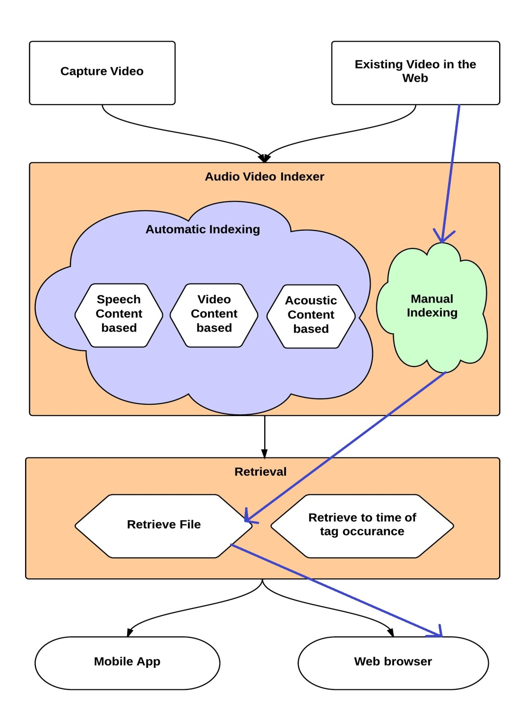

Figure 10: End to end flow implemented in 5th Sem

Implemented flow is marked by violet arrows.

### Web Client for Indexing YouTube Videos

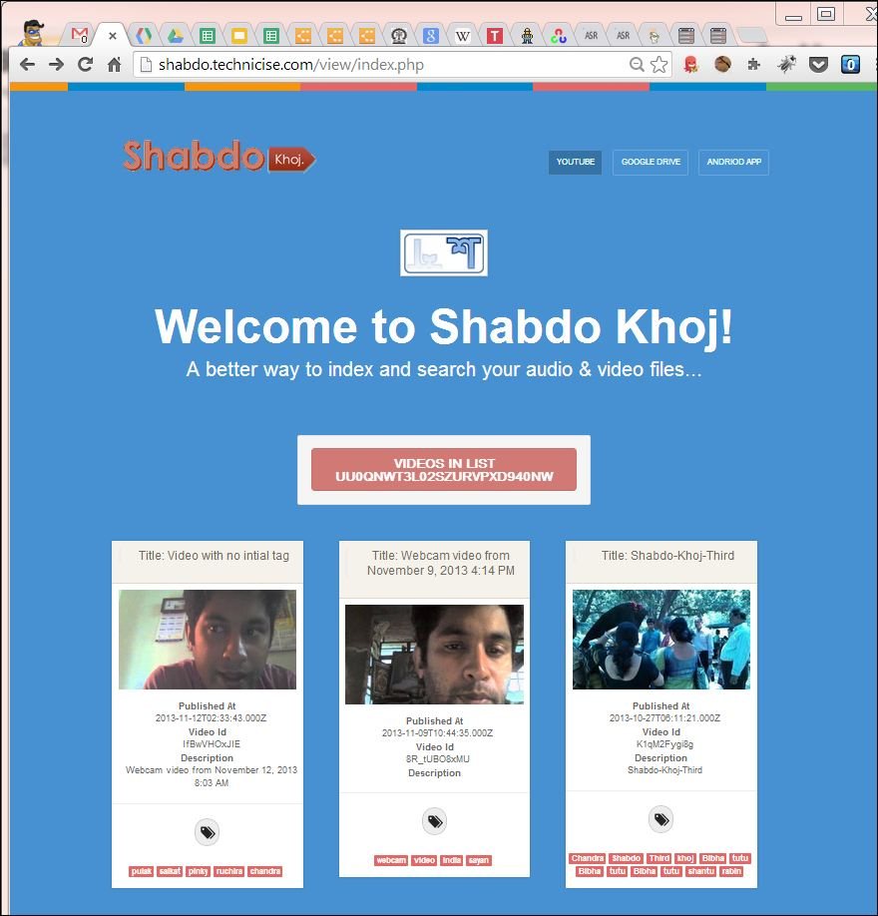

Figure 11: Web Client for Indexing YouTube Videos

### Video Access from Devices

#### Windows App for Video Access

|  |
| --- |
| **Place Holder for Diagram** |

#### Android App for Video Access

|  |
| --- |
| **Place Holder for Diagram** |

#### iOS App for Video Access

|  |
| --- |
| **Place Holder for Diagram** |

### Algorithms & Workflow

* Algorithm for determining index keys out of Recognized Speech Content
* Workflow of Speech content & Image Object extraction
* Overall framework for indexing audios/videos

## Work In Progress:

### Image Object extraction

I am using [OpenCV](http://opencv.org/) framework to detect image objects from video frames

### Clients for Accessing Videos

* Android App with above mentioned features
* Desktop Uploader App with above mentioned features

### Research newer index keys

* Speaker Information as Index key
* Acoustic information as index keys

## Work to be done in 6th Sem

1. Use [CMU Sphinx](http://cmusphinx.sourceforge.net/) to extract speech content
2. One flow of Video Content Based Automatic Indexing(Extract Image Objects from video and tag celebrities present in a video)
3. One flow of Acoustic information Based Automatic Indexing
4. End to end Desktop Uploader App and Enhance Web Client for Indexing
5. Retrieve to time of tag occurrence

## Future Scope

1. Integration With Vimeo & other video sharing website (Netflix , ustream, box.com, Dropbox , Google Drive)
2. Gamification of Video Indexing while video capture by mobile devices
3. Search Engine Optimization of Indexed Video/Audio files
4. Exclusive Indexing and tagging of Music Files
5. Integration of Tags file with [EXIF](http://owl.phy.queensu.ca/~phil/exiftool/TagNames/MIE.html) MIE metadata
6. Integration of Tags file with Operating System [Search Index](https://technet.microsoft.com/en-us/library/dd744682(v=ws.10).aspx#WS_DeployingSearchConnectors)es

# Conclusions

In this approach, we are extracting information about the video and audio content of the file from various aspects. Then we are determining most suitable tags and attaching them with file so that we can search & retrieve this file based on those tags. This initiative will provide better searching options for video and audio file. Implementation this approach will provide an extendible framework for Audio, Video Indexing which can be enhanced & customized by developers and users respectively.

# References

[1] <http://allthingsd.com/20110601/cisco-the-internet-is-like-really-big-and-getting-bigger/>

[2] <http://www.omg-facts.com/Technology/In-2010-Google-Had-Only-Indexed-004-Of-T/52586>

[3] GUOJUN LU , “Indexing and Retrieval of Audio: A Survey”

[4] Christopher Kuner, Fred H. Cate, Christopher Millard and Dan Jerker B. Svantesson , “The challenge of ‘big data’ for data protection”, <http://idpl.oxfordjournals.org/content/2/2/47.extract>

[5]<http://www.cisco.com/en/US/solutions/collateral/ns341/ns525/ns537/ns705/ns827/white_paper_c11-520862.html>

[6] Websites:

* http://en.wikipedia.org/wiki/Query_by_humming
* http://www.midomi.com/
* http://www.soundhound.com/
* http://en.wikipedia.org/wiki/Tunebot
* http://en.wikipedia.org/wiki/Musipedia
* http://www.kecl.ntt.co.jp/csl/sirg/people/yasushi/SoundCompass.pdf
* http://en.wikipedia.org/wiki/Parsons_code
* http://music.cs.northwestern.edu/index.php
* http://tunebot.cs.northwestern.edu/index.php
* http://www.musipedia.org/
* http://en.wikipedia.org/wiki/Acoustic_fingerprint
* http://en.wikipedia.org/wiki/Shazam_(service)
* http://www.speech.kth.se/wavesurfer/
* http://audacity.sourceforge.net/
* http://www.hongkiat.com/blog/25-free-digital-audio-editors/
* https://incus.greenbutton.com/
* http://maart.sourceforge.net/
* https://sourceforge.net/projects/camel-framework/
* https://sourceforge.net/projects/jaudio/
* http://www.speech.kth.se/snack/
* http://research.microsoft.com/en-us/projects/mavis/
* http://googlesystem.blogspot.in/2008/09/google-audio-indexing.html
* http://en.wikipedia.org/wiki/Google_Audio_Indexing
* http://googleblog.blogspot.in/2008/09/google-audio-indexing-now-on-google.html
* http://www.autonomy.com/content/Technology/evolution/evolution-of-search/index.en.html
* http://techcrunch.com/2008/09/17/google-launches-audio-indexing/
* http://en.wikipedia.org/wiki/Multimedia_search
* http://en.wikipedia.org/wiki/Audio_search_engine
* http://www.playaudiovideo.com/pav_start.htm
* http://www.ramp.com/
* http://en.wikipedia.org/wiki/Google_Voice_Search
* http://music.cs.northwestern.edu/index.php
* http://www.aurix.com/pages/3417/Technology.htm
* http://www.apple.com/ios/siri/
* http://en.wikipedia.org/wiki/Siri_(software)
* http://www.cisco.com/en/US/solutions/collateral/ns341/ns525/ns537/ns705/ns827/white_paper_c11-520862.html
* http://mashable.com/2012/03/06/one-day-internet-data-traffic/
* http://hadoop-karma.blogspot.in/2010/03/how-much-data-is-generated-on-internet.html
* http://www.scientificpsychic.com/workbook/chapter2.htm
* http://www.omg-facts.com/Technology/In-2010-Google-Had-Only-Indexed-004-Of-T/52586
* http://googleblog.blogspot.in/2008/07/we-knew-web-was-big.html
* http://idpl.oxfordjournals.org/content/2/2/47.extract
* http://www.internetworldstats.com/stats7.htm
* <http://www.fiercewireless.com/story/idc-future-mobile-device-user-input/2010-05-03>
* http://www.audiblemagic.com/
* http://www.neurostechnology.com/
* http://www.linkedin.com/company/musiwave
* http://www.crunchbase.com/company/musiwave
* http://mashable.com/2007/11/15/musiwave-microsoft-deal/
* http://www.microsoft.com/en-us/news/press/2007/nov07/11-12ProjectTunesPR.aspx
* http://www.lumenvox.com/resources/tips/historyOfSpeechRecognition.aspx
* http://www.pcworld.com/article/243060/speech_recognition_through_the_decades_how_we_ended_up_with_siri.html?page=2
* https://www.dropbox.com/developers/chooser
* http://www.dropboxwiki.com/Main_Page
* http://support.google.com/drive/bin/answer.py?hl=en&answer=2500820
* http://infolab.stanford.edu/~backrub/google.html
* http://www.google.co.in/intl/en/insidesearch/howsearchworks/thestory/
* http://www.google.co.in/intl/en/insidesearch/howsearchworks/algorithms.html
* <http://www.wired.com/insights/2013/10/google-hummingbird-where-no-search-has-gone-before/>
* <http://royal.pingdom.com/2013/01/16/internet-2012-in-numbers/>
* <http://variety.com/2014/digital/news/netflix-streaming-eats-up-35-of-downstream-internet-bandwidth-usage-study-1201360914/>
* http://www.cs.tut.fi/~moncef/publications/c-b-multimedia-indexing-paris.pdf
* http://citeseerx.ist.psu.edu/viewdoc/download?doi=10.1.1.208.1129&rep=rep1&type=pdf
* <https://www.fxpal.com/publications/talkminer-a-lecture-webcast-search-engine.pdf>
* <ftp://ftp.hpl.hp.com/pub/dec/CRL/publications/jmvt/speechbotRIAO2000.pdf>
* <https://www.tineye.com>
* <https://www.bing.com/images/>
* <https://images.google.com/>
* <http://www.technorms.com/39812/bings-image-match-feature-lets-reverse-search-images>